Balachandran, Ryan 4/21/2022
Course Number: PHYS.1410L
Section Number: 804
Instructor: Dr. Mittler
Partners(s): Did it alone

One-Dimensional Collisions
Part 1: Results and Analysis
1A/1B: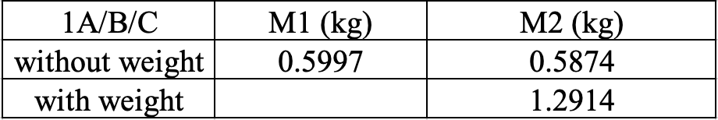
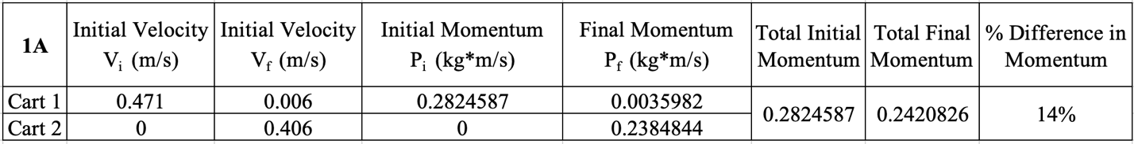
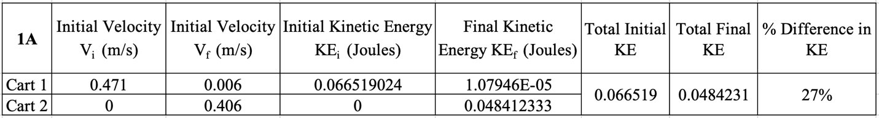
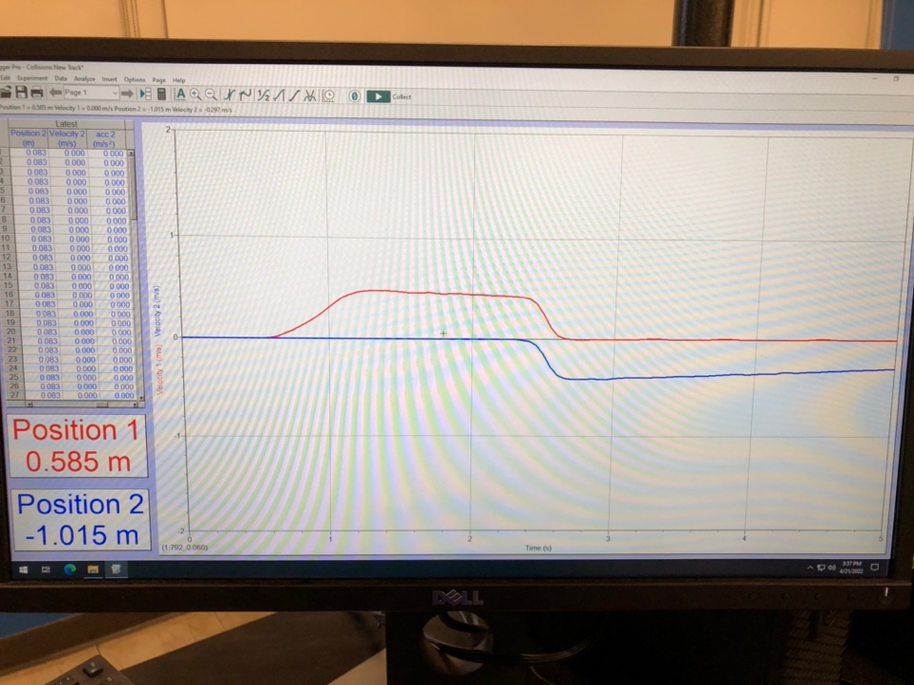
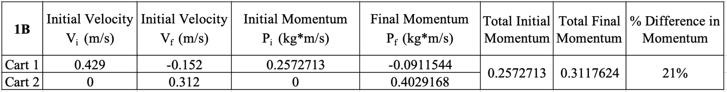
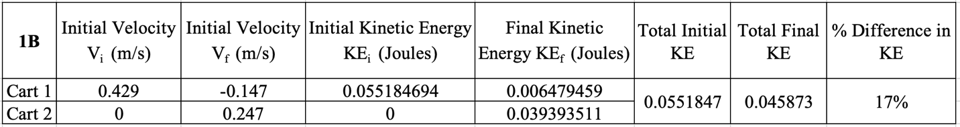
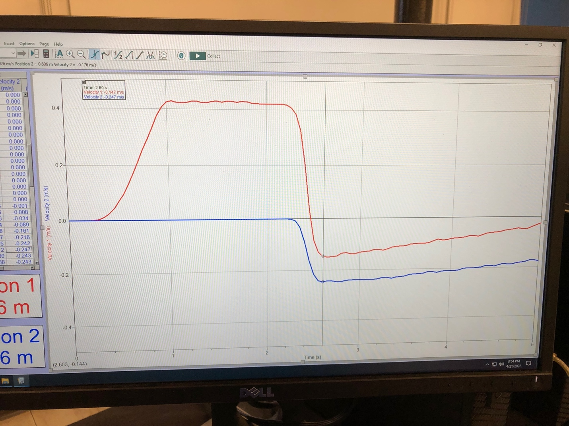

Part 1C
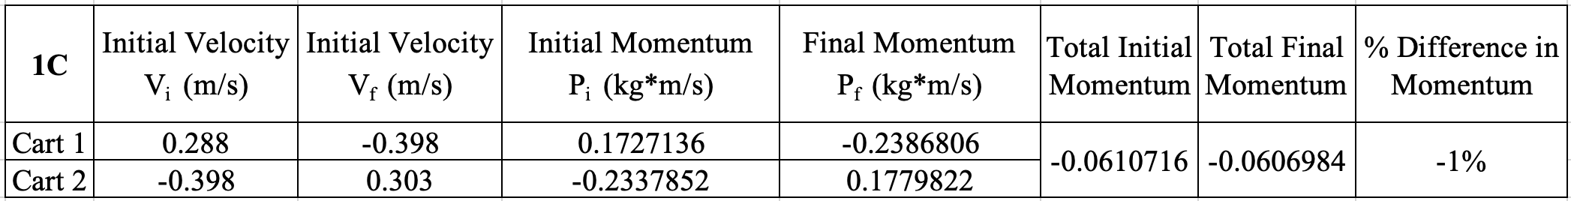
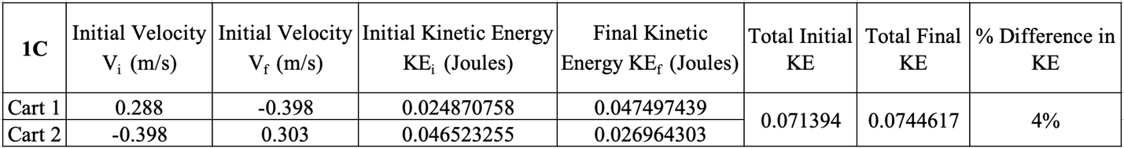
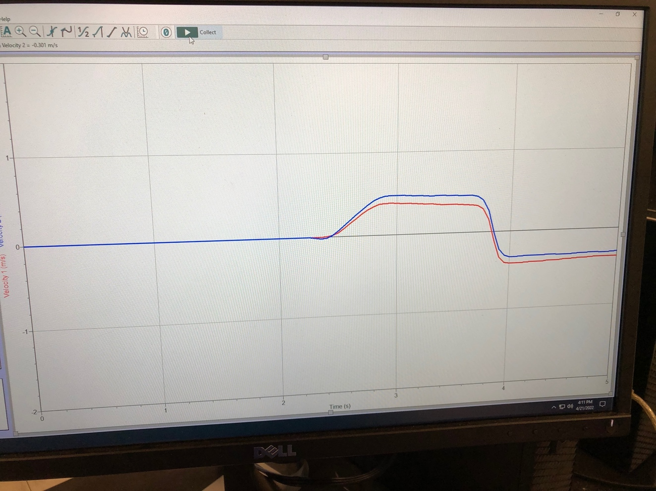
In part C, both cart 1 and cart 2 were pushed with relatively equal force towards each other. For velocity, I made the x axis positive in the direction of cart 1, so cart 2’s velocity would be negative. After the initial push, cart 1’s velocity would be positive and cart 2’s velocity would be negative in relation to where I placed the positive x axis. I pushed cart 2 with a bit more force than cart 1, but after they collided and pushed each other back, cart 1 inherited cart 2’s negative velocity and cart 2 inherited cart 1’s positive velocity, albeit slightly faster. With the percent difference in momentum and kinetic energy being less than 5, we can see from the theorem that this is an elastic collision.
Part 1: Discussion
1A/1B: In part 1 of the experiment, momentum and kinetic energy is somewhat conserved. Because of the starting conditions of the experiment, and errors in recording the data, the percent difference in momentum is 14% and the percent difference in kinetic energy is 27%. When conducting the experiment of pushing cart 1 while cart 2 is stationary, the theoretical outcome is for cart 1 to stop when colliding with cart 2, transferring its momentum and kinetic energy. Due to friction and varying degrees of force used to push cart 1, the conservation of momentum and kinetic energy is not perfect, but can be clearly seen as cart 1 slows down to a near stop while cart 2 gains cart 1’s momentum and kinetic energy.

1C: Because I did this experiment alone, I wasn’t able to record the most ideal data, but what I got was pretty good anyway. With cart 1 and cart 2 being pushed at the same time, the theory is that they will gain each other’s velocity and move in the opposite direction. The data from table 1C confirms this along with the conservation of momentum and kinetic energy. Any energy or momentum lost was due to kinetic friction or varying force in which each cart was pushed with.

Part 2: Results and Analysis
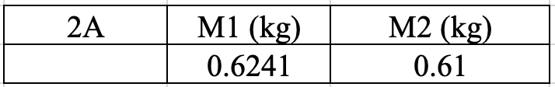
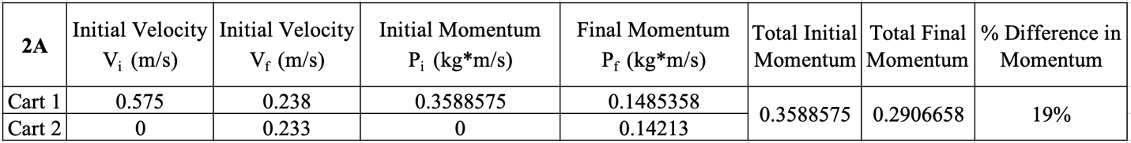
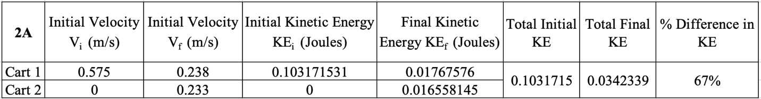
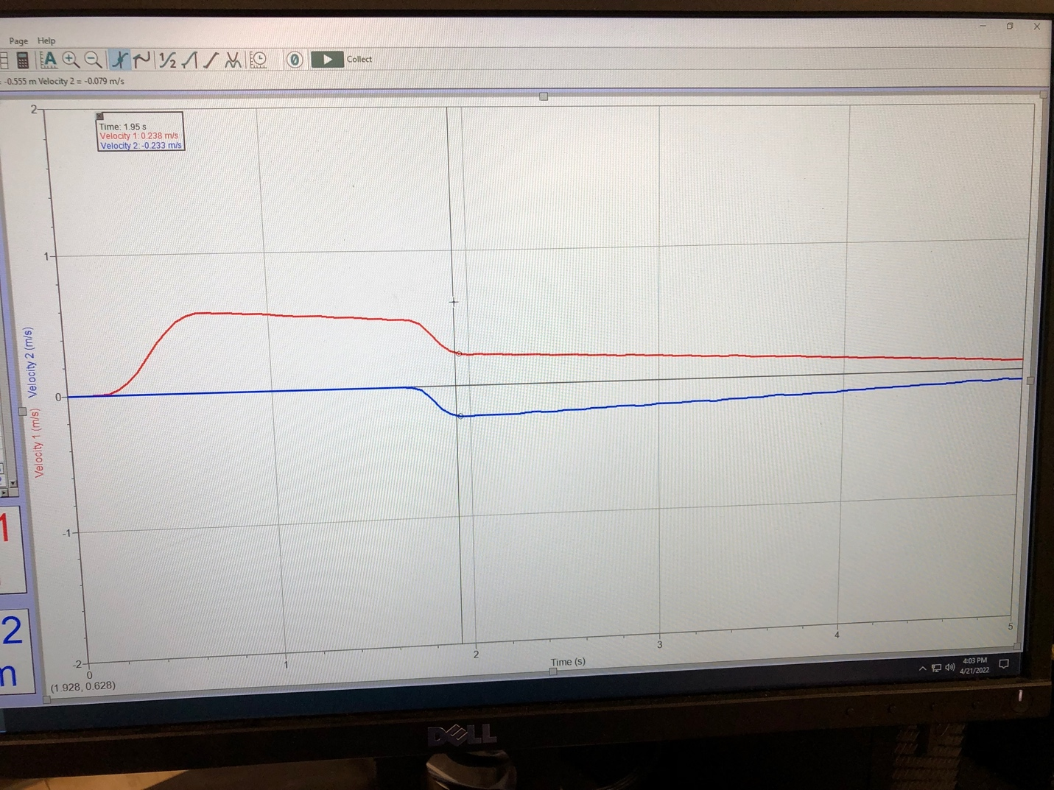
Part 2: Discussion
The total momentum was somewhat conserved. Due to the Velcro, the carts stuck together upon collision before losing velocity but continued to move forward in the positive x direction. The kinetic energy however was not conserved very well, with a percent different of 67%. This is because the initial kinetic energy was shared with cart 2 upon collision. The velocity of cart 1 was cut in half, transferring to cart 2.
Conclusion
In part 1 C, the total momentum and kinetic energy of the system was conserved almost perfectly, while in part A and B, the total momentum and kinetic energy was not perfectly conserved. This is due to cart 2 being stationery and cart 1 being pushed. Because cart 2 is stationery, cart 1 transfers its momentum and energy to cart 2, and in part B, with the added mass to cart 2, this causes cart 1 to move backwards after colliding with cart 2. Compared with part 1C when both carts are moving, any loss in momentum and kinetic energy is due to the collision as momentum and energy from cart 1 is transferred to cart 2.

In part 2, the total momentum and kinetic energy of the system was not conserved due to it being an inelastic collision. With Velcro being attached to each cart, a lot of momentum and kinetic energy is lost due to the carts sticking together during collision. Cart 1’s velocity is cut in half, transferring about half its momentum to cart 2 and dropping its kinetic energy drastically. While the percent change in momentum is less than 20%, the percent change in kinetic energy is nearly 70%, with most of that being lost during the collision as they stick together.

